SPEAKER BIOS
Bryan Clark 2
Michael Roberts 3
Michael Carter 4
Sarah Froman 5
Kevin Stork 6
Geoff Bowman 7

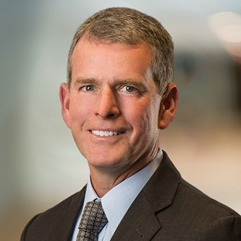

Bryan Clark

Hudson Institute
Director of the Center of Defense and Technology

Bryan Clark is a senior fellow and Director of the Center for Defense Concepts and Technology at Hudson Institute. He leads studies there in naval operations and fleet architecture, electronic warfare, autonomous systems, military competitions, 5G telecommunications, and command and control. Before joining Hudson Institute, Bryan was a senior fellow at the Center for Strategic and Budgetary Assessments (CSBA), where he led studies for the DoD Office of Net Assessment, Office of the Secretary of Defense, and Defense Advanced Research Projects Agency on new technologies and the future of warfare. Prior to joining CSBA, he was special assistant to the Chief of Naval Operations and director of his Commander’s Action Group, where he led development of Navy strategy and implemented new initiatives in electromagnetic spectrum operations, undersea warfare, expeditionary operations, and personnel and readiness management. During his 25-year Navy career, Bryan was an enlisted and officer submariner, serving in afloat and ashore submarine operational and training assignments including tours as chief engineer of two nuclear submarines and operations officer at the Navy’s nuclear power training unit. He has a Master of Science degree in national security studies from the U.S. National War College, a Bachelor of Science degree in chemistry and philosophy from the University of Idaho and conducted graduate research in chemistry at the University of Washington.
Bryan may be reached by email at: bclark@hudson.org

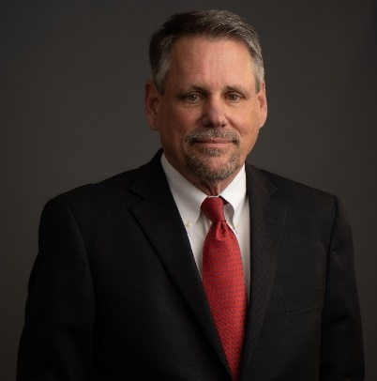

Michael Roberts

Hudson Institute and Navy League’s Center for

Maritime Strategy
Senior Fellow

Based in Washington, D.C., and Jacksonville, Florida, Mike Roberts is a Senior Fellow at the Hudson Institute and a Non-resident Senior Fellow at the Navy League’s Center for Maritime Strategy. His work is focused on the national and economic security concerns raised by China’s growing dominance of the commercial maritime industry. Prior to 2022, Roberts held legal and executive roles with Crowley Maritime Corp. for thirty years, both in-house and as outside counsel. He was a member of Crowley’s Senior Leadership team for thirteen years as General Counsel and SVP-Government Relations. In 2020-2021 Roberts also served as Chairman and President of the American Maritime Partnership (AMP), a broad coalition representing America’s domestic maritime industry. Roberts is an industry leader on maritime legal and policy issues, including the Jones Act, competition laws, workforce development, and other matters. Roberts testified several times before Congress, published numerous articles, hosted podcasts and presented at many industry and media events. As General Counsel Roberts handled the legal, government relations and insurance affairs of the company. He played leadership roles in expanding the company’s government contracting work, developing an insurance line of business and founding the Crowley Cares charitable foundation. Roberts’s key priority for AMP was to raise awareness of China’s maritime ambitions and the need for an effective American response. He hosted podcasts with experts including Admiral James Stavridis, Ambassador Robert O’Brien, Dr. Michael Pillsbury, Rep. Mike Gallagher, naval expert Bryan Clark and others. Other priorities include legislation affirming that U.S. laws apply to offshore wind development on the Outer Continental Shelf, updated waiver procedures launching a maritime grassroots initiatives including the Florida Maritime Partnership. Growing up in western Michigan, Roberts interned at the US Court of Appeals, DC Circuit while an undergraduate at Michigan State University. Following graduation, he worked for US Sen. Robert Griffin and the US Justice Department’s Antitrust Division while obtaining his law degree. Roberts spent several years in private law practice focused on transportation regulatory and legislative matters. In 1991 Roberts moved in-house with Crowley as Counsel for the liner division and later as VP for Government Relations. He returned to private practice in 2000, representing Crowley and others until moving back in-house in 2008 as SVP / GC and a member of the Crowley leadership team.
Michael Roberts may be reached by email at: mike@mg-roberts.com
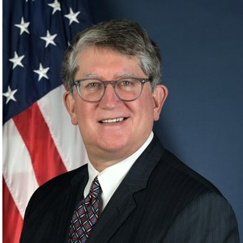

Michael Carter

U.S. Department of Transportation, Maritime Administration

(MARAD)
Associate Administrator for Environment and Compliance

Michael Carter is the Associate Administrator for Environment and Compliance at the Department of Transportation, Maritime Administration (MARAD). In this role, he provides oversight to the Office of Environment, Office of Safety and the Office of Maritime Security. For the last 24 years, Mr. Carter also continues to serve as the Director of the Office of Environment, providing leadership for the Agency’s environmental compliance responsibilities, shaping MARAD’s program to assist maritime transportation stakeholders in addressing key environmental challenges and support maritime transportation innovation. Mr. Carter is responsible for implementing the Agency’s Maritime Environmental and Technical Assistance (META) Program, which focuses on collaborative research and technology testing, evaluation, and demonstration specific to addressing the unique characteristic of maritime operations. He and his staff maintain a strong international presence on these same issues serving in various capacities on the US Delegation to the IMO Marine Environment Protection Committee (MEPC) and the International Organization of Standardization (ISO). Before joining the Maritime Administration in August 1995, Mr. Carter was in a private environmental law practice. He received his law degree from Catholic University in 1985 and his undergraduate degree in Forestry and Wildlife Management from Virginia Polytechnic Institute and State University in 1982.

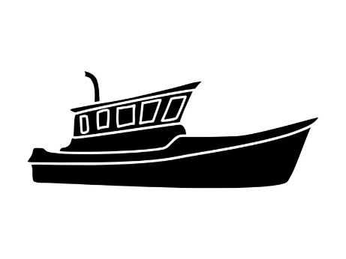

Sarah Froman

U.S. Environmental Protection Agency
Policy Advisor, Office of Transportation and Air Quality

BIO NOT AVAILABLE

Sarah may be reached by email at: froman.sarah@epa.gov

Kevin Stork

U.S. Department of Energy

BIO NOT AVAILABLE

Kevin may be reached by email at:
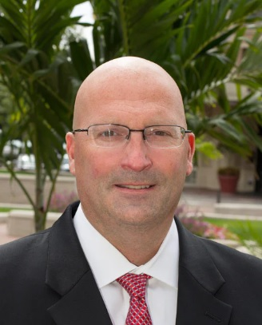

Geoff Bowman

Van Scoyoc Associates
Vice President

Geoff Bowman is one of the nation's leading policy professionals on water resources and infrastructure policy. Having spent 15 years as a Professional Staff Member on the House Transportation and Infrastructure Committee, Geoff offers clients an insider’s perspective on the policy, players, and politics involved in those issues. Geoff was most recently the Staff Director of the House Transportation and Infrastructure Committee’s Water Resources and Environment Subcommittee, where he shepherded passage of the Water Infrastructure Improvements for the Nation (WIIN) Act of 2016. Prior to that, he was instrumental in the passage of WRDA 2007 and WRRDA 2014. Geoff has also worked closely with the many federal agencies under the Committee’s jurisdiction, including the Army Corps of Engineers (Corps), the Tennessee Valley Authority, the Saint Lawrence Seaway Development Corporation, the National Oceanic and Atmospheric Administration, the Natural Resources Conservation Service, the International Boundary Water Commission, the Agency for Toxic Substances and Disease Registry, and the Environmental Protection Agency (EPA).
Mr. Bowman may be reached by e-mail at: mailbox@vsadc.com or by phone at (202) 638-1950

