

VIA FACSIMILE

May 8, 2008

The Honorable Michael J. Madigan
Illinois General Assembly
6500 South Pulaski Road
Chicago, IL 60629

Dear Speaker Madigan:

We, the undersigned Illinois-based waterways operators, are writing to respectfully request your help in resolving unanswered questions about the impact of H.B. 5157 on our industry before the bill moves forward.

Unfortunately, the purpose is of this bill remains unclear. The legislative record describing this initiative’s intent does not answer the basic questions of who will be affected by the bill, what situation it is intended to address, and when it will be applied. Therefore, we ask that these simple, yet critical questions be clearly answered before the legislation is permitted to advance.

One circumstance concerning the bill that is clear, however, is its direct conflict with the Federal Arbitration Act. If H.B. 5157 becomes law, we can be certain that it will face a court challenge. That challenge will cost the taxpayers of Illinois and the state’s business community significant yet unnecessary resources.

Thank you for your attention to this matter. We look forward to further conversations with you as the details of the legislation become clearer. Please do not hesitate to contact any of us.

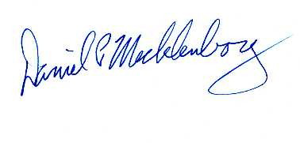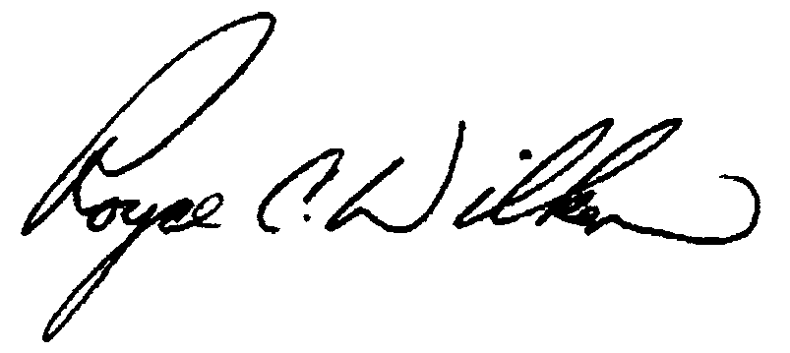
Dan Mecklenborg Royce Wilken
Ingram Barge Company American River Transportation Co.
Collinsville, IL Decatur, IL
(615)298-8209 (800) 637-5843

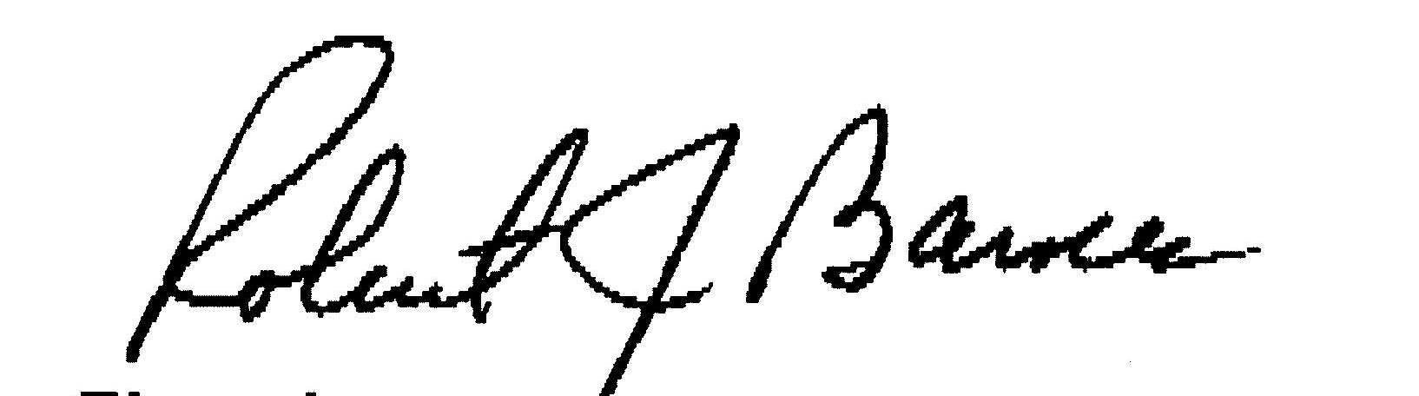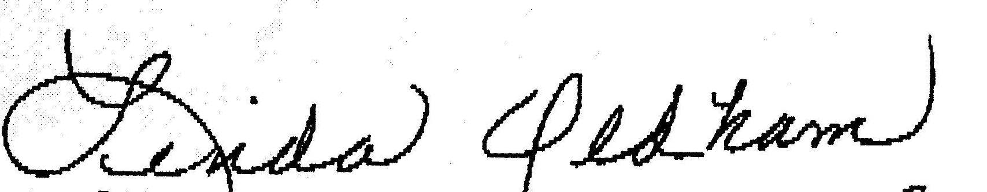

Robert J. Barnes Linda Oldham
Illinois Marine Towing, Inc. Shawneetown Harbor Service, Inc.
Lemont, IL Shawneetown, IL
(630) 257-3400 ext. 12 (618) 269-3095

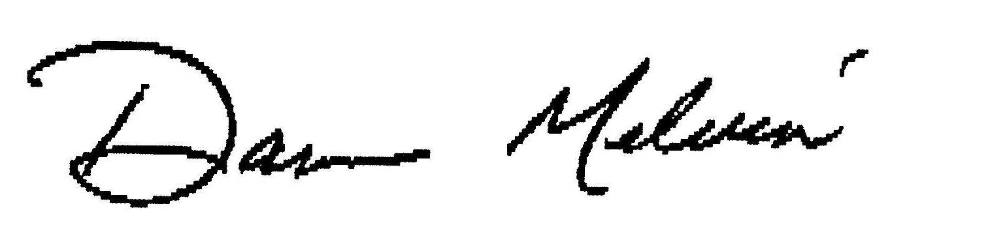
Darren Melvin Delbert Wilkins
Hanson Material Service Canal Terminal Company
Lockport, IL Channahon, IL
(815) 838-3421 (815) 521-3570

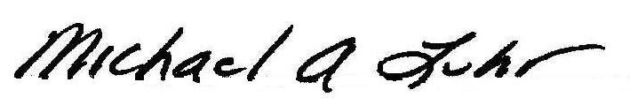
C. Barry Gipson Michael Luhr
National Maintenance & Repair, Inc. Luhr Bros. Inc.
Hartford, IL Columbia, IL
(618) 254-7451 (618)281-4106

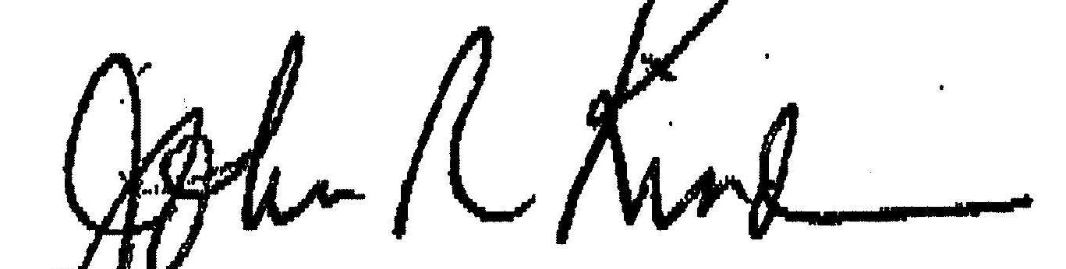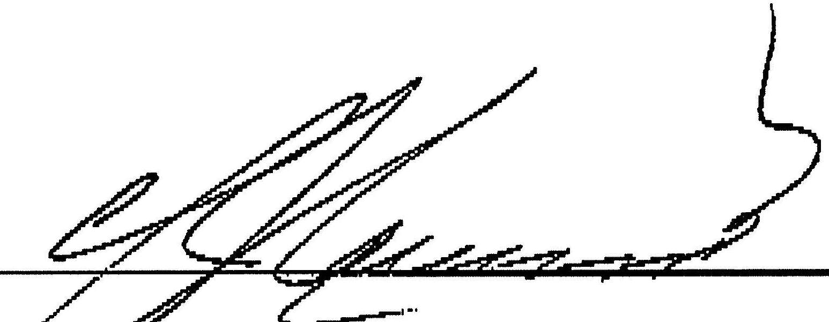
John Kindra Charles Norman
Kindra Lake Towing, LP Norman Brothers, Inc.
Chicago, IL Alton, IL
(630)963-1988 (618) 465-6455

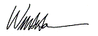
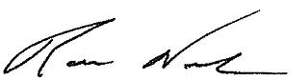

Bill Hanson Ron Novak
Great Lakes Dredge & American Commercial Lines
Dock Company, LLC Lemont, IL
Oak Brook, Il (630) 257-2317
(630) 574-3000

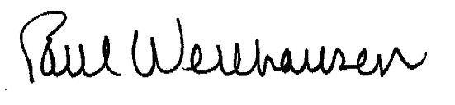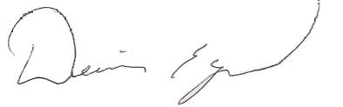

Paul Wellhausen Dennis Egan
Lewis & Clark Marine, Inc. Egan Marine Corporation
Granite City, IL Lemont, IL
(618)876-1116 (630) 739-0947

